CURRICULUM VITAE

mohd. YUSUF
Add :Vill+Post Sultanpur Dost, Teh – Thakurdwara,
Dist Moradabad, UP 244001
Email ID : yusufmohd231@gmail.com
Contact : +917500072052

Objectives:

To join an organization in a high growing industry that provide opportunities to learn and grow and attain highest of responsibility, where I can contribute to the growth of the company.

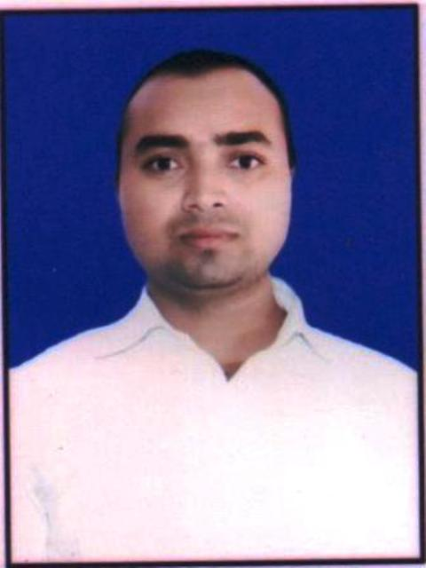
Educational Qualification:

✪ B.A (MJPRU) Bareilly
✪ Intermediate from (U.P) Board
✪ Matriculation from (U.P) Board
✪ ‘O’ Level – Computer course from NIELIT
✪ ‘CCC’ – Computer course from NIELIT
✪ Accounting with Tally from INSTITUTE
✪ Electrician from DDU-GKY & QUESS CORP.
Computer proficiency:

Application Package : MS Office (Excel, World…) CorelDraw, Photoshop, Busy etc
Operating System : Windows XP / Windows 7/8/10s
Internet : Excellent Internet Proficiency
wORKing experience:

2017 – 2018, 1 YEAR Computer Operator ( Tally & Excel Accounting )
COMPANY NAME – Finesse Again, House no-7, Mg Road Sector-14, Gurgaon Haryana 122001
2020 – CURRENT – Computer Operator & Laser Marking Operator
COMPANY NAME - Vijay Vallabh Metals, Mndi Chowk,/(Kothiwal Nagar) Moradabad, UP244001

Personal Information:

Date of birth : 11-03-1996
Father’s Name : Mohd.Yaqub
Marital status : Unmarried
Nationality : Indian
Sex : Male
Language known : Hindi & English
Interpersonal skills : Hardworking, honest & sincere

I hereby declare that the above information furnished by me is true and correct to the best of my knowledge.

Place :- (MOHD.YUSUF)
Dated:-

